ME 4470 Wind and Ocean Energy Final

# Month of January

803 Datalines read, 802 Datapoints kept, 120 Datapoints duplicated.

Solution found! You need 6 Turbines.

Storage Capacity: 50.384 MW, with a starting point of 100.00%

That's equivalent to 0.10 hours on a 500 MW thermal power plant!

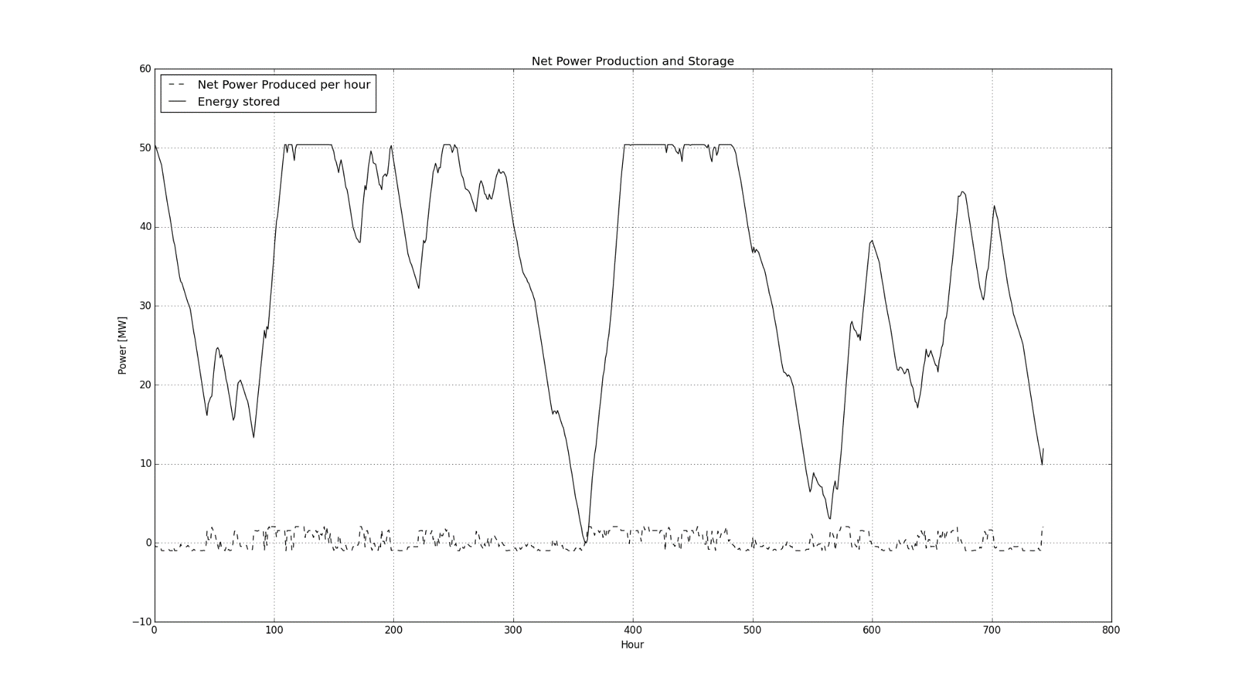

# Month of July

806 Datalines read, 805 Datapoints kept, 139 Datapoints duplicated.

Solution found! You need 6 Turbines.

Storage Capacity: 36.518 MW, with a starting point of 100.00%

That's equivalent to 0.07 hours on a 500 MW thermal power plant!

